“Railway Ticket Booking System”

A PROJECT REPORT

Submitted by

PATEL DISHANK KUMAR NITINBHAI ET24MTCA043

PATEL VIVEK KUMAR ROSHANBHAI ET24MTCA054

PATEL DHRUV RAJESHBHAI ET24MTCA041

SONI ANANT RAJESHKUMAR ET24MTCA064

**Under the Guidance Of**

“Prof. Margee Rawal”

In fulfillment for the subject Software Project-1 (MTCA16106)

Master of Computer Application

At



Sarvajanik College of Engineering & Technology, Surat

December, 2024

|  |  |  |
| --- | --- | --- |
| SCET ARCHITECTURE | **Sarvajanik Education Society**  **Sarvajanik College of Engineering & Technology, Surat.**  **Master of Computer Application Department**  **Academic Year 2024-25** | A description... |

Date:

CERTIFICATE

This is to certify that the project entitled “Railway Ticket Booking System” has been submitted by Patel Dishank Kumar N. (ET24MTCA043), Patel Vivek Kumar R. (ET24MTCA054), Patel Dhruv R. (ET24MTCA041) & Soni Anant R. (ET24MTCA064) towards fulfillment for the subject Software Project-1 (MTCA16106) in 1st Semester of MCA of Sarvajanik University, Surat during the academic year 2024-25.

|  |  |
| --- | --- |
| Guide Name: Prof. Margee Rawal |  |
| **(Guides’ Signature)** | **Prof. Gayatri Kapadia**  **Head, M.C.A. Department** |

|  |  |  |  |
| --- | --- | --- | --- |
| Examiners’ Signature:  1.__________________________ |  |  |  |
| **2.__________________________** |  |  |  |

**Acknowledgements**

Team Effort is the only key to success. Success cannot be achieved single-handedly. So, we would like to express our sincere thanks to all the dignitaries involved in making this project a great joy and turning it into a successful work.

We would like to take the opportunity to thank my college **Sarvajanik College of Engineering and Technology** for giving us this tremendous opportunity to work in the real-time project.

**Prof. Riddhi Patel** our professor and project coordinator, has been very prudent to us throughout our college studies. He is the person who has been giving direction to our work and the shape of our imagination. We express our regards to him from the core of our hearts.

We also like to thank our H.O.D. **Prof. Gayatri Kapadia** and all the professors who are always ready to give best guidance. They are the individuals who give solutions whenever required. We would also like to acknowledge all our friends and colleagues, team members for their help and encouragement from time to time. The constant support and encouragement of my friend deeply appreciates. The project indeed gave challenging and exhilarating experience in designing and developing the required system.

Finally, we would like to thank our parents for their support throughout the project. We owe a special debt to our family & friends for their supports blessing and encouragement for us.

**INDEX**

|  |  |  |
| --- | --- | --- |
| **Sr.No** | **Content** | **Page No.** |
| **1.** | **Project Abstract** | 1 |
| **2.** | **Objective** | 3 |
| **3.** | **Software Specification** | 5 |
| **4.** | **Database Design/ File System (Table Designs)** | 7 |
| **5.** | **Diagrams (Use Case Diagram and Activity Diagram)** | 9 |
|  | **5.1 Admin Use Case Diagram** | 10 |
|  | **5.2 User Use Case Diagram** | 11 |
|  | **5.3 Admin Activity Diagram** | 12 |
|  | **5.4 User Activity Diagram** | 13 |
|  | **5.5 ER Diagram** | 14 |
| **6.** | **System Flow Chart** | 15 |
| **7.** | **Source Code** | 21 |
| **8.** | **Testing** | 22 |
| **9.** | **References** | 23 |

**1. Project Abstract**



**ABSTRACT**

The Railway Ticket Booking System is an application developed to simplify and streamline the ticket booking process for passengers. This system, developed in C, manages and stores all the booking-related data in an efficient manner, ensuring a reduction in errors and time-consuming tasks that were common in manual systems. The primary goal of this system is to provide a reliable, secure, and user-friendly platform for booking railway tickets.

The system has two types of logins: Administrator and Client. The administrator manages the overall system operations, including client data, ticket bookings, and access control. The client, on the other hand, can register and book tickets by selecting destinations, coach types, and other preferences.

This system was created to address issues like data redundancy, difficulty in handling multiple files, and inefficiencies in manual ticket booking processes. It offers secure access to sensitive information, with only the administrator having the authority to modify or update data. The client can view and manage their booking details through their login.

The system ensures accurate data handling and eliminates the need for redundant entries, offering a smooth experience for users. By automating the process of ticket booking, the system is more reliable and reduces the chances of errors, providing a more efficient and organized way to manage bookings.

**2. Objectives**



**Objectives:**

The primary objective of a Railway Ticket Booking System is to simplify and automate the process of booking train tickets, making it more efficient and user-friendly. It aims to reduce the complexities associated with manual booking and provide a smooth experience for both passengers and administrators. Here’s a breakdown of its goals:

* Efficient Ticket Booking Process
* Revenue Management
* Reduces Communication Gaps
* Destination and Coach Management
* Passenger Information Handling
* Organizes and Simplifies Booking Tasks
* Centralized Data and Easy Access

**3. Software Specification**



**Software Specification**

|  |  |
| --- | --- |
| Language | C Language |
| Operation System | Windows 11 |
| Tools | Dev C++ |

**4. Database Design / File System (Table Design)**



**Admin Database Design:**

|  |  |
| --- | --- |
| **Admin Register** | **Admin Login** |
| Admin Full Name | Admin Email Id |
| Admin Contact Number | Admin Password |
| Admin Address |  |
| Admin Email Id |  |
| Admin Password |  |
| Admin Repeat Password |  |

**User Database Design:**

|  |  |
| --- | --- |
| **User Register** | **User Login** |
| User Full Name | User Email Id |
| User Contact Number | User Password |
| User Address |  |
| User Email Id |  |
| User Password |  |
| User Repeat Password |  |

**Ticket Booking Database Design:**

|  |
| --- |
| Tourist Name |
| Tourist Age |
| Select Destination |
| Select Coach [AC & Non-AC] |
| Select Food [Veg & Non-Veg] |
| Counts of Tickets |
| Show Ticket Price |
| Payment Process |
| Payments Amount |
| Payment Id |
| Payment Process |

**5. Diagrams**



**Use Case Diagram:**

**5.1 Admin Use Case Diagram**

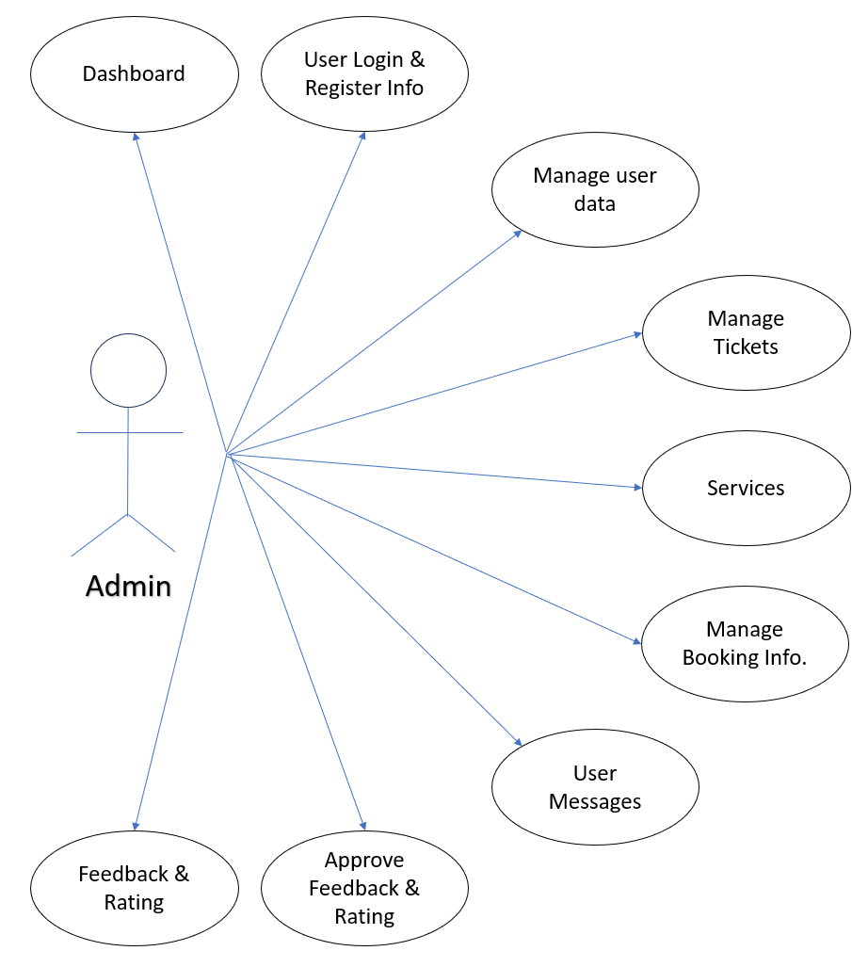

**[Admin Use Case Diagram]**

**5.2 User Use Case Diagram:**

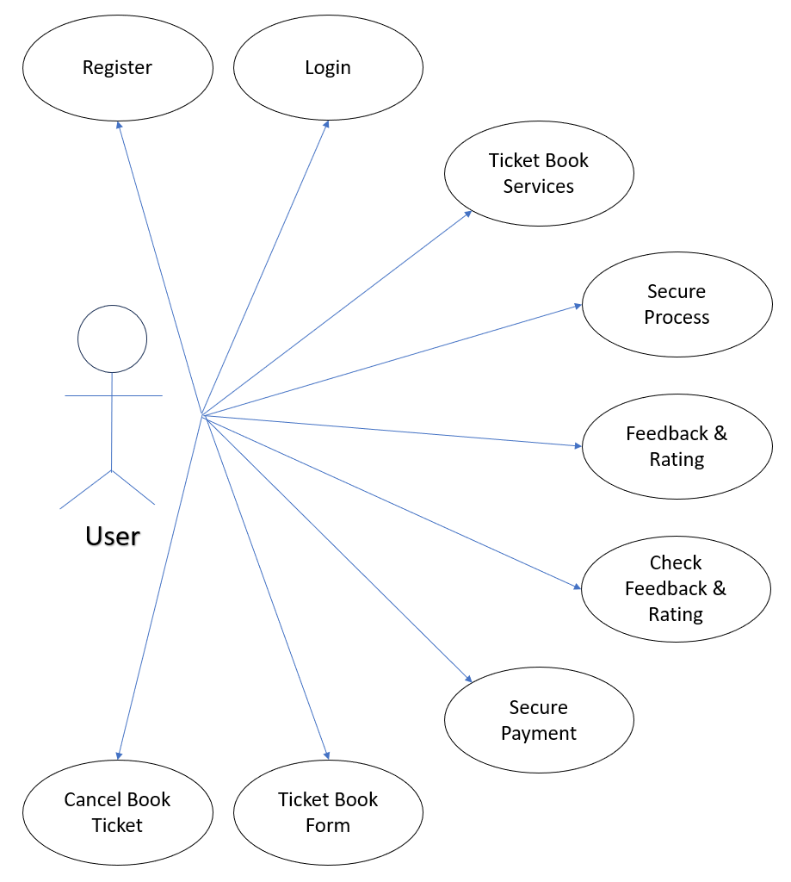

**[User Use Case Diagram]**

**Activity Diagram:**

**5.3 Admin Activity Diagram:**

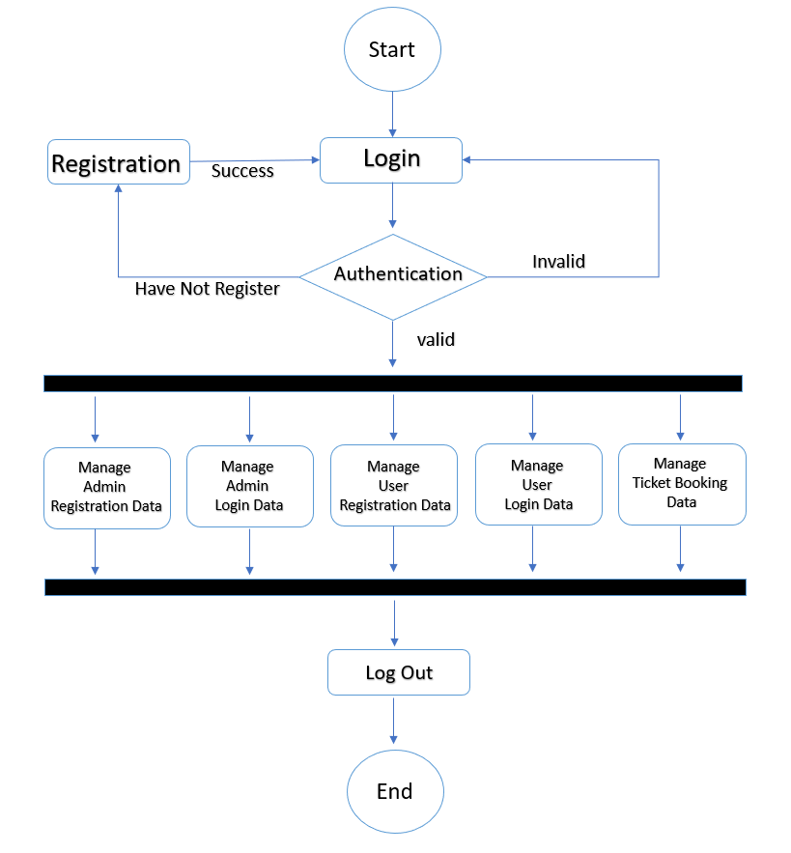

**5.4 User Activity Diagram:**

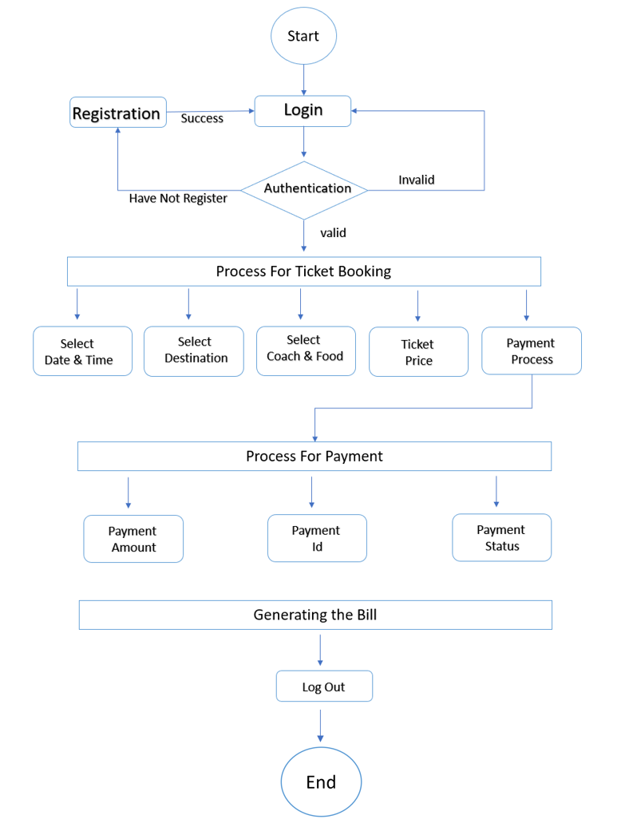

**5.5 ER Diagram**

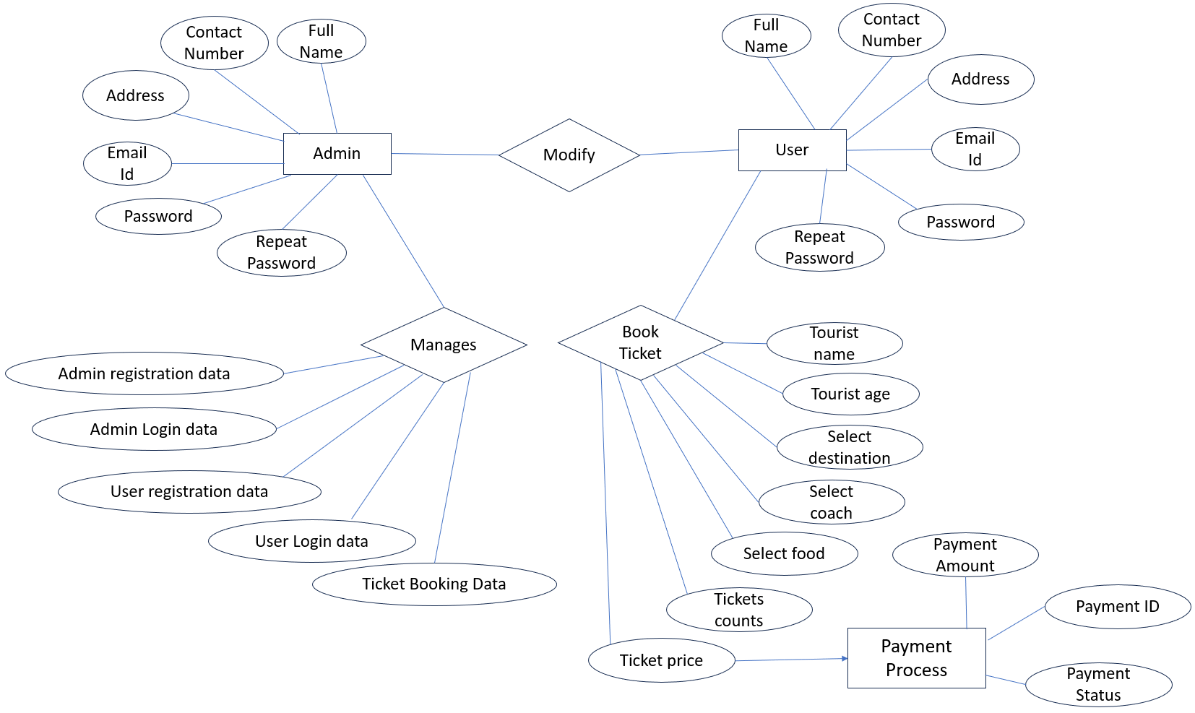

**6. System Flow Chart**

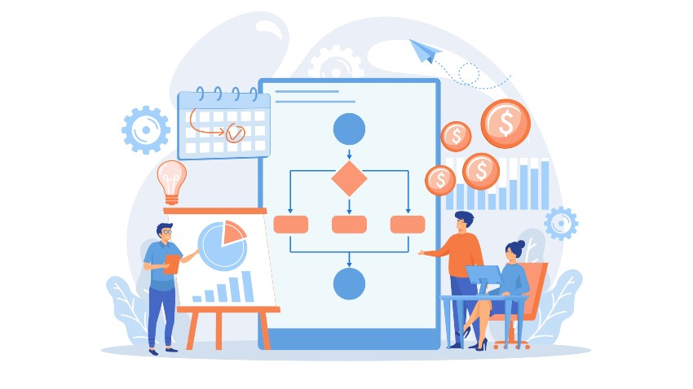

**Screenshots:**

**Admin Registration & Login:**

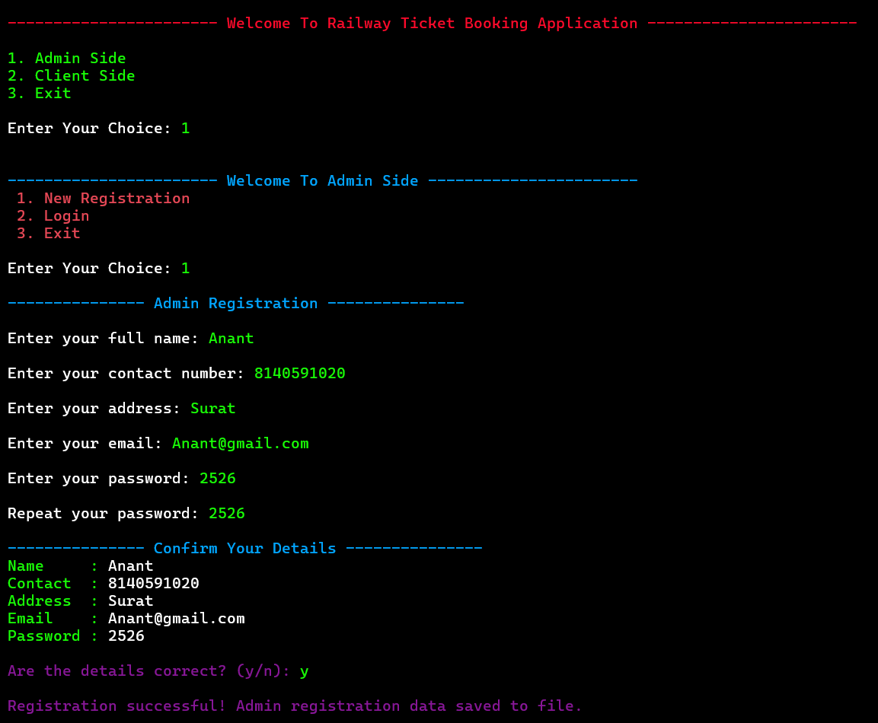

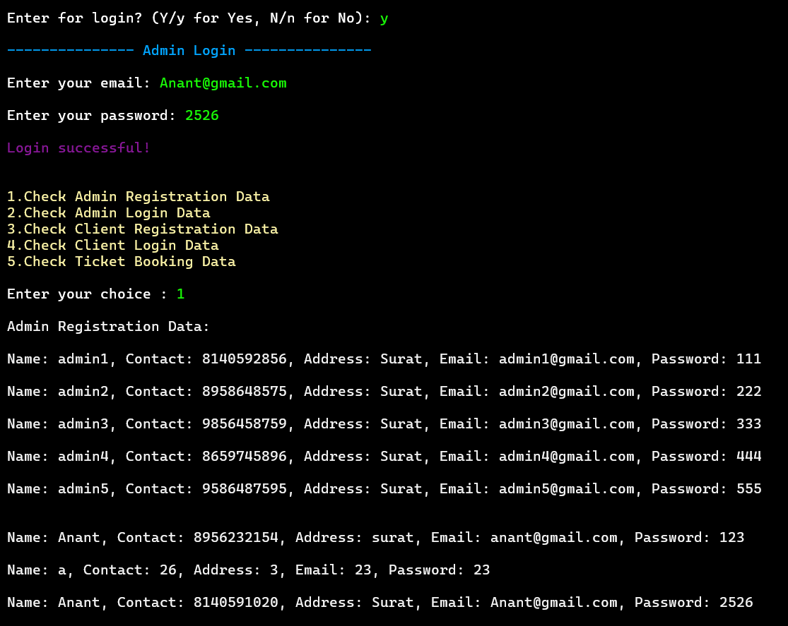

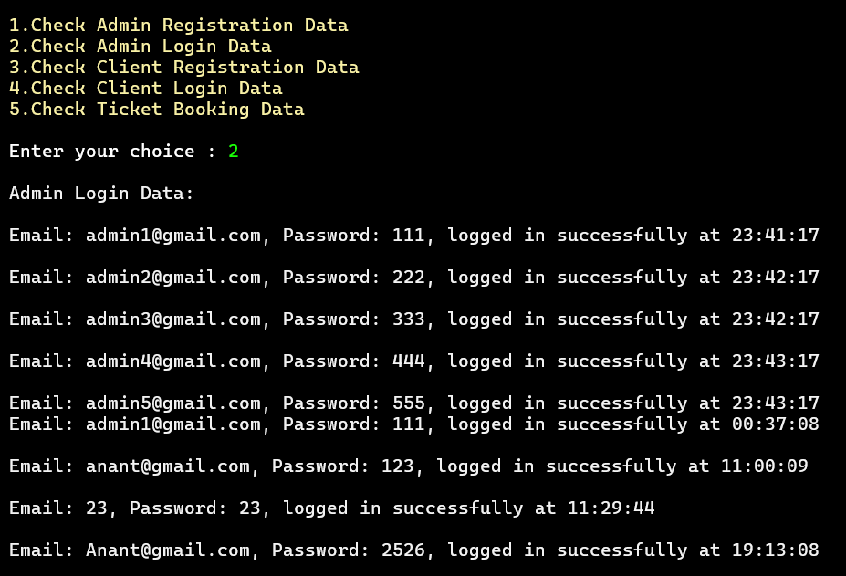

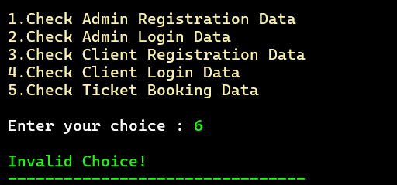

**User Registration & Login:**

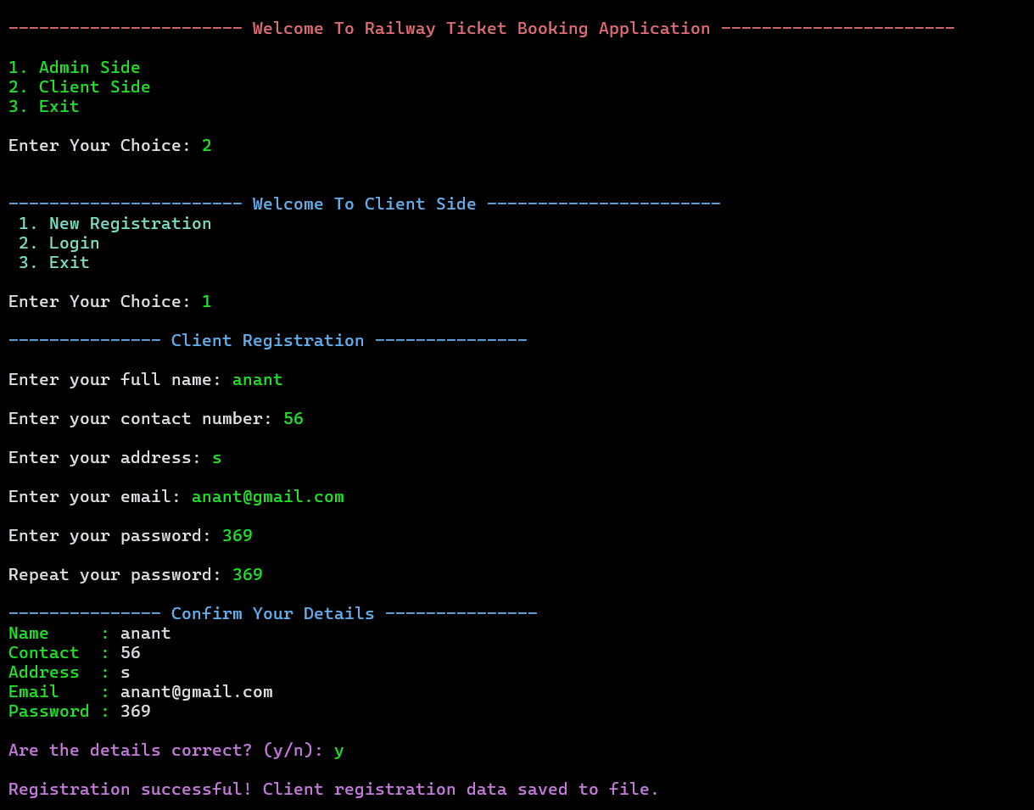

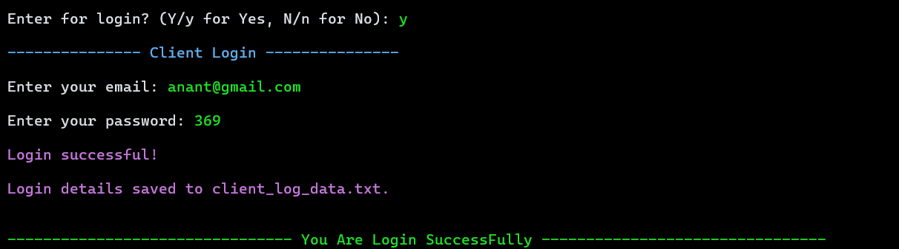

**Ticket Booking Process:**

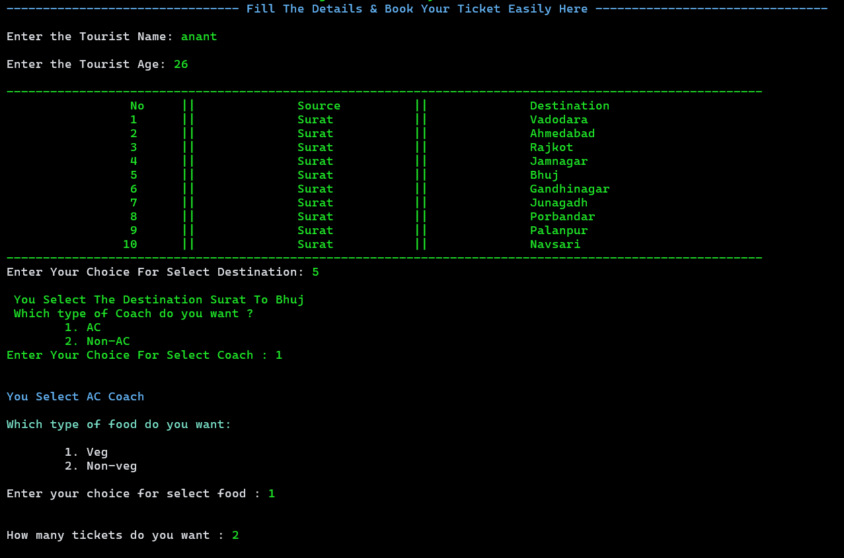

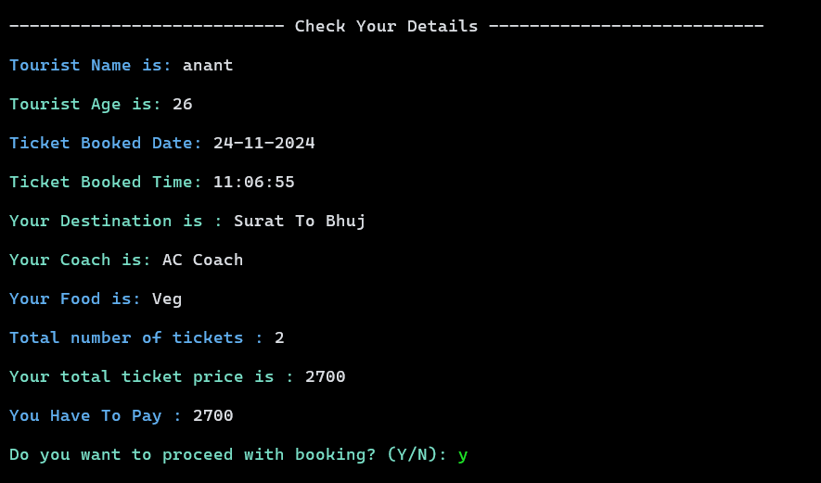

**Ticket Generated:**

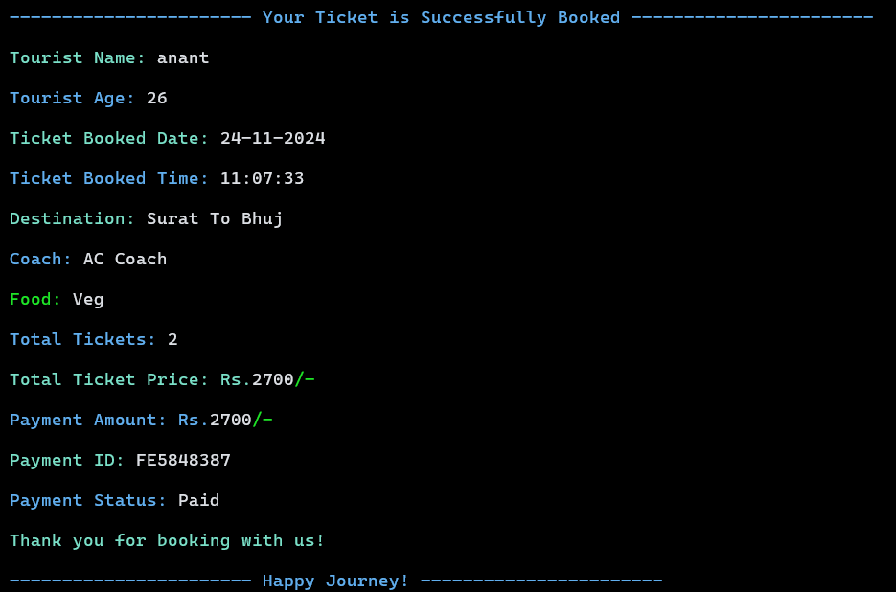

**7. Source Code**



**8. Testing**



**9. References**

* + - www.studytonight.com
    - www.drawio.com
    - www.cppreference.com
    - www.scaler.com/topics/c/file-handling-in-c/